**1. Social Media Pictures**

* NeedPictures and also need to add YouTube URL-
* Youtube-<https://www.youtube.com/channel/UCFsWTpPL4iu-Vb9EL8zNkiQ?view_as=subscriber>
* Instagram-<https://www.instagram.com/etechvidhya/?igshid=9aupladr7oly>
* Linkedin-<https://www.linkedin.com/feed/>
* Facebook-<https://www.facebook.com/etechvidhya>
* Twitter-<https://twitter.com/home>

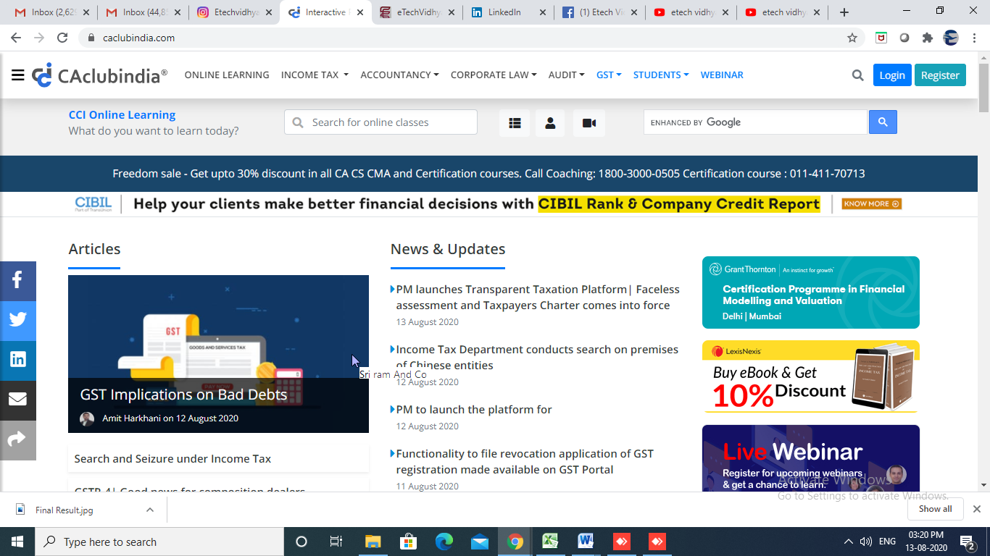

**2. Change in Logo-Change in Tab**



**4. Sequence of Tabs**

* Home
* Join Our Courses
* Services
* Bulletin Board
* **Host a webina**r
* Contact us
  + **Under host a webinar it should link to contact us page**
  + **Linking of Our service to Contact us page- See Excel**

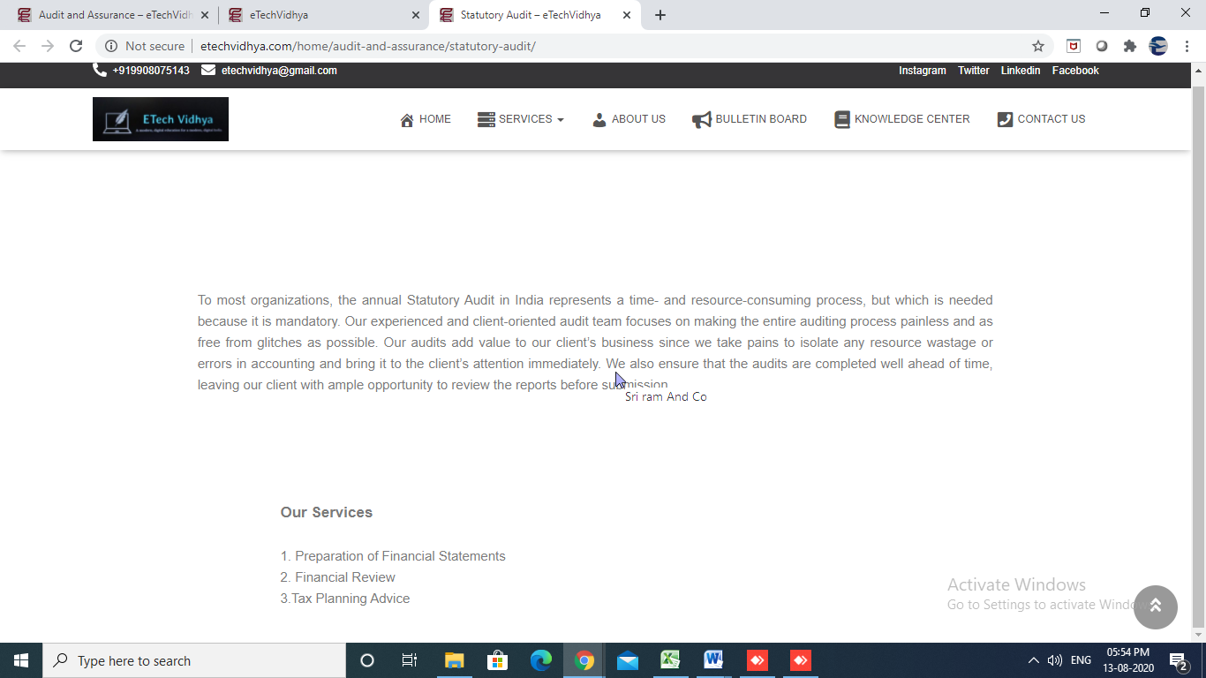

**Remove this from Home page**

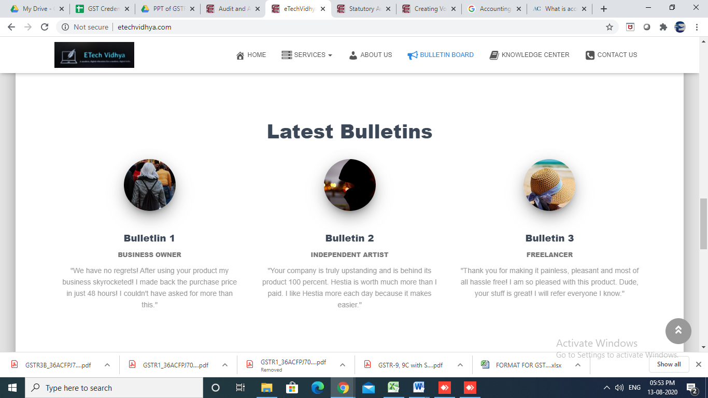

**8. Home page also Tagline to be added**

* **Learning is Success, Service is our Motto**
* **Remove Background Picture as we need to put website as plain white and professional and content should be in black colour and Blue**
* **Change in website colour as per the logo**

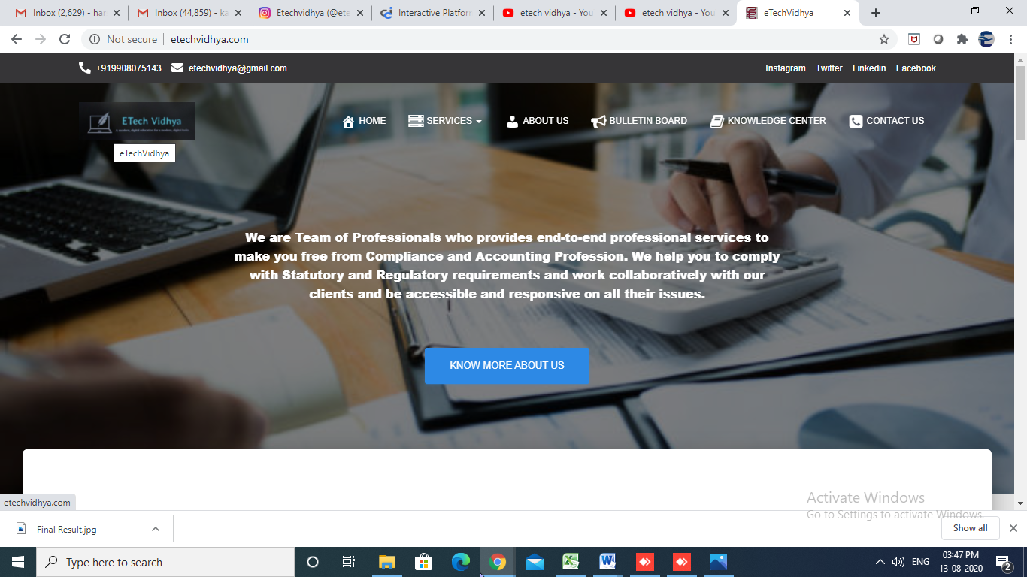

**10. Under Services tab there is no sub heading Linkage and also in the below Screenshot**

**Please also add Join Our Courses**

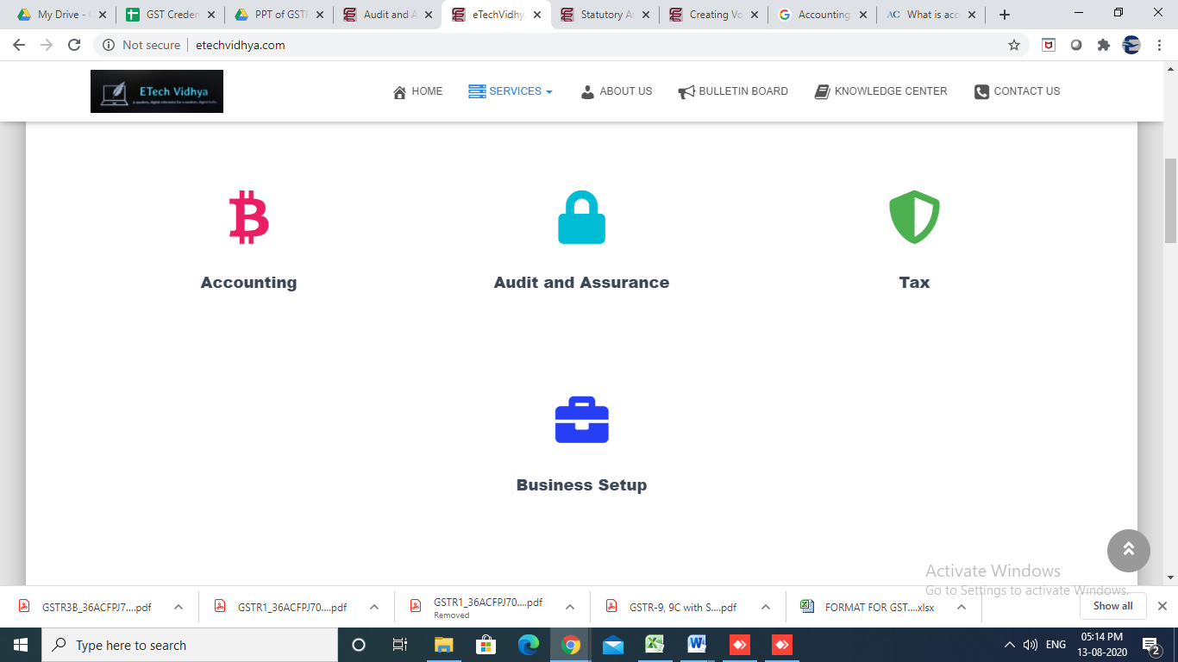

**11. Add additionally Join our Courses in First**

**Change in below pictures for**

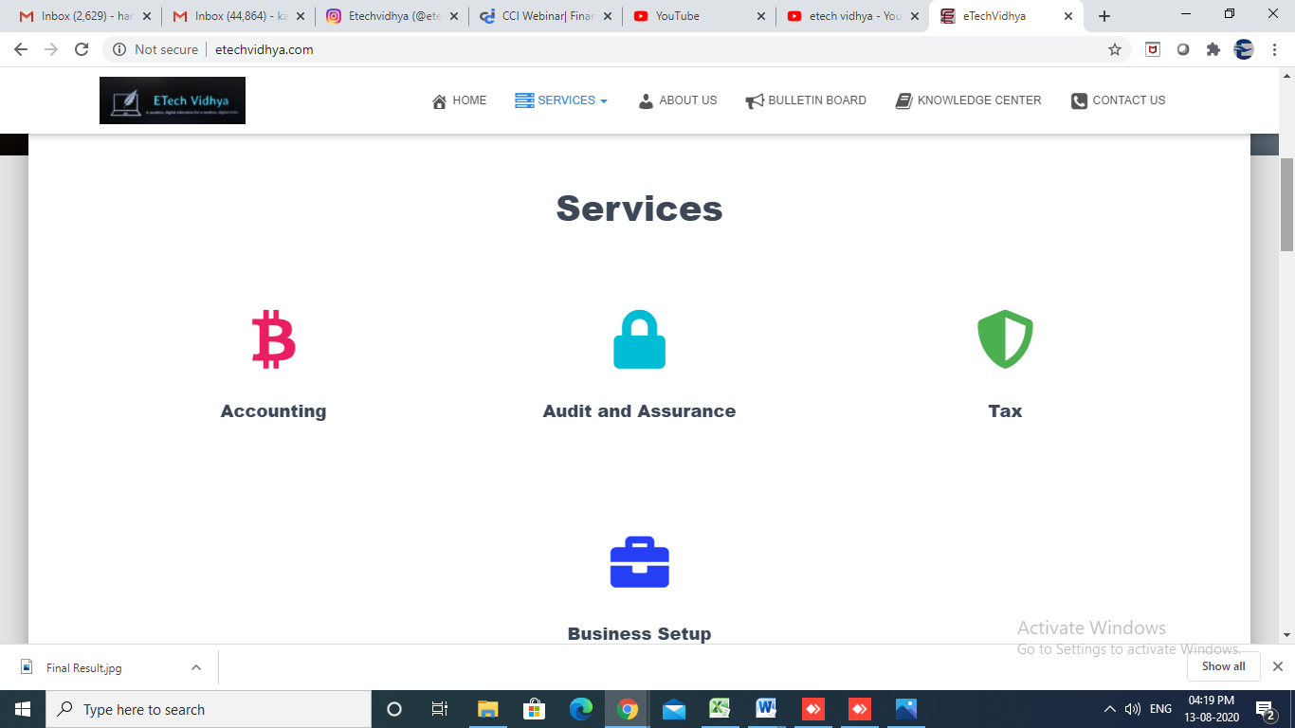

* **Join Our Courses**



* **Accounting**



* **Audit and Assurance**



* **Taxes**



* **Business Set up**



12. In the last line of website can you please put Disclaimer as (This Website has been prepared for informational purposes only, and is not intended to provide, and should not be relied on for any advice)

13. Please Remove our personal Social Media sites under the about us page.

Please change the Timings-11.00 Am to 7.00PM

Also remove name and Phone Number

Please add mail id- [etechvidhya@gmail.com](https://mailto/)

Add Mail Image



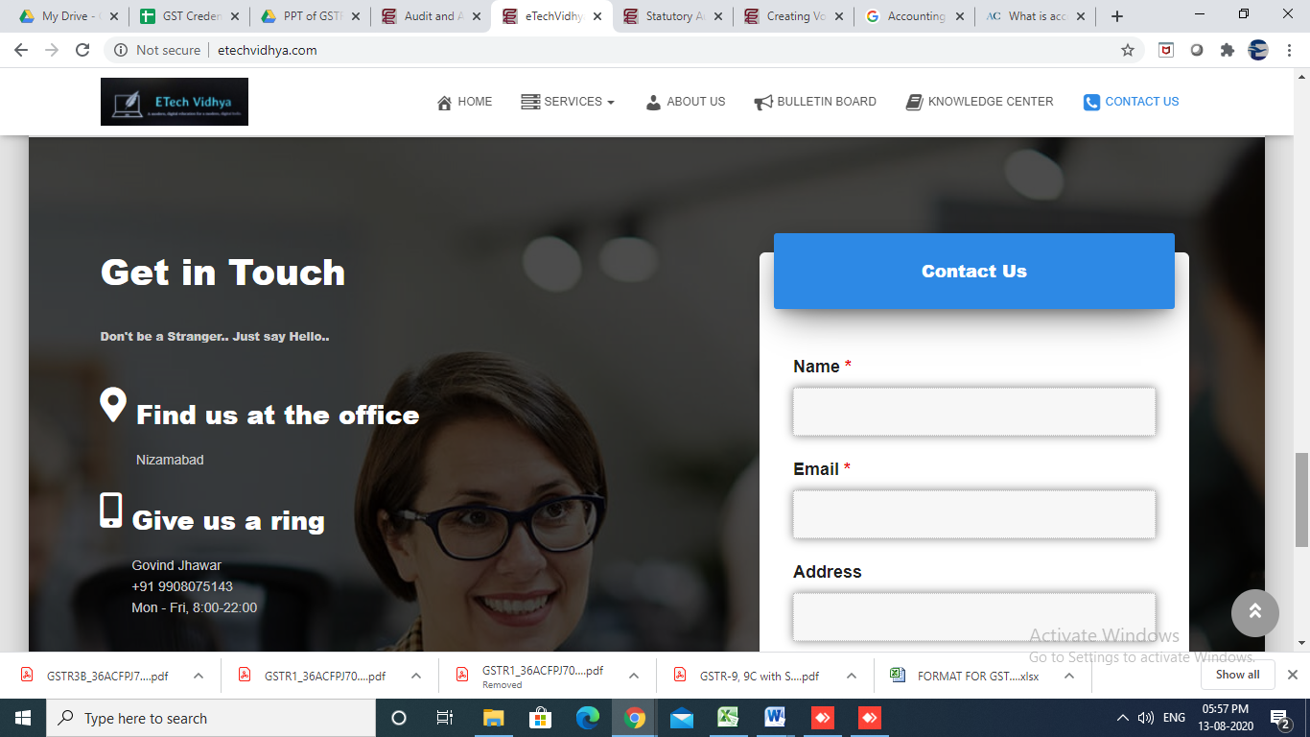

16. Message from the contact us page is not reaching to [etechvidhya@gmail.com](mailto:etechvidhya@gmail.com) Cross checked the same-Please confirm

17. Remove top line of social media connect rather make like CA Club attached Screenshot for reference.- <https://www.caclubindia.com/webinar/>

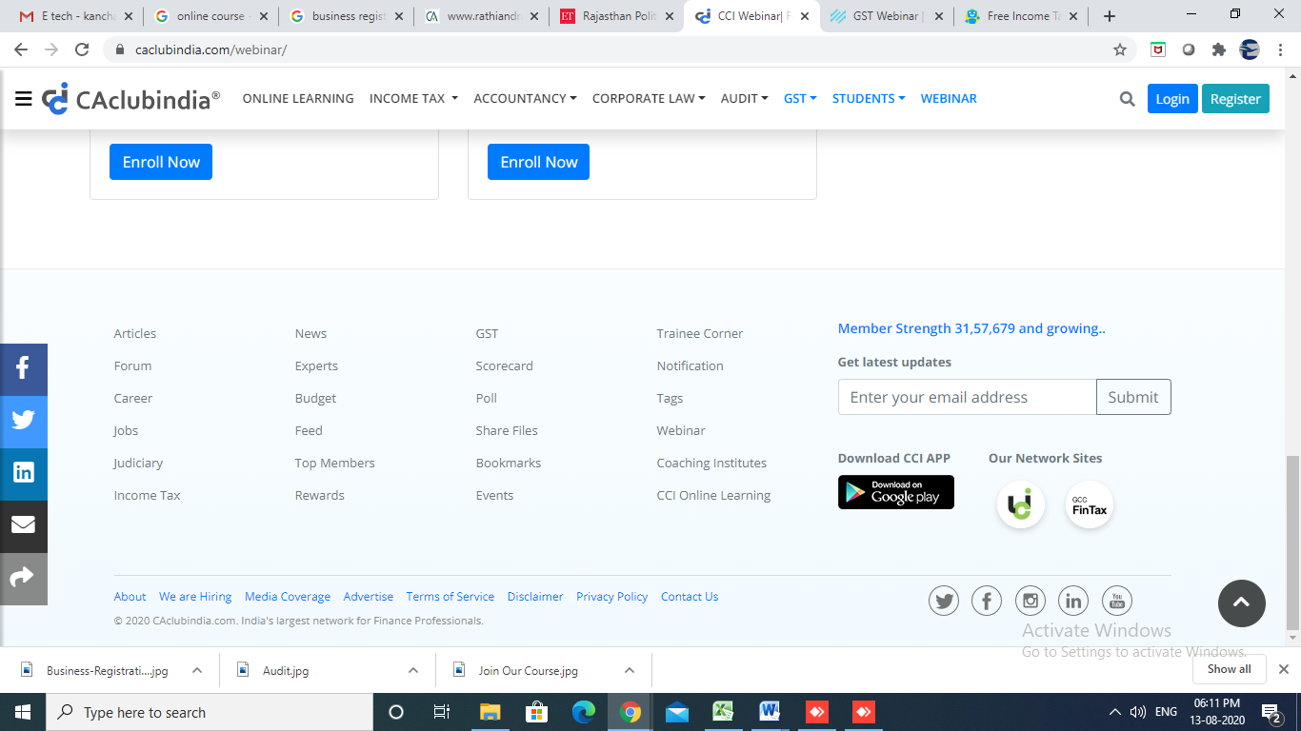

18. Under Contact us page add additionally new line as you are (below Screenshot)

* CA/CWA/CS/CMA
* Advocate
* Tax Practitioner
* Accountant
* Article
* Tax Consultant
* Business men
* Professional
* Student
* Other if then Explain

